Introduction
The United States & Latin Veterans Support Embassy is similar to a permanent diplomatic mission, and it is at a much higher level than the NGO (Non-Governmental Organisation) it used to be; therefore, it should be built internally to reflect this prestigious identity and operate accordingly. The above concept is the cornerstone in this initial guiding plan and will be its main focus towards a universally unified entity. All different aspects of the embassy operations that need attention are linked to each other and should be dealt with in harmony considering their natures. The key-word upgrade can be the best approach in most cases, while add/replace words are suitable for other areas. The Embassy’s Message & Statement is the essence of the intended operation, where the mission and vision shall draw the roadmap, while the administrative hierarchy should perfectly execute them into concrete deeds. The clarity of the new identity and statement are instrumental to successful building operation, and the technology is the driving force towards this success. Automation, communications, global networking, and openness are necessities, while human development remains the ultimate tool and the most valuable asset. This guiding plan aims to point the direction towards the noble goals, and all concerned parties have to participate, involve, and contribute to the comprehensive plan of action that will remain our beacon and guiding force for years to come.

Security Infrastructure
The Commercial Facilities Sector
This includes a diverse range of sites that draw large crowds of people for shopping, business, entertainment, or lodging. Facilities within the sector operate on the principle of open public access, meaning that the general public can move freely without the deterrent of highly visible security barriers. Most of these facilities are privately owned and operated, with minimal interaction with the federal government and other regulatory entities.

As the coronavirus pandemic continues to take its toll on populations and economies around the globe, governments and private industries are harnessing real-time monitoring solutions and artificial intelligence to mitigate the spread. However, these surveillance technologies also bring up a litany of concerns related to privacy, civil liberties, and data collection. Will governments and private industries deactivate these monitoring systems once the situation normalizes or is the proverbial panoptic genie out of the bottle?

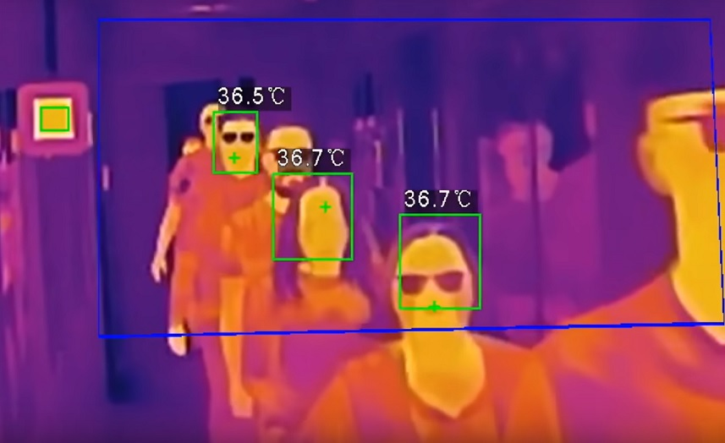

Combating the coronavirus with real-time data costs $94,650.00 per month.

The software company, Vantiq, sees itself at the forefront of the effort to mitigate the spread of the coronavirus, but not by accident. Currently, the company and its partners are using a host of technologies including artificial intelligence, thermal imaging, facial recognition, IoT sensors, and more to develop operational systems and applications for clients around the globe which USLVSE will have access to and be operating from.
The Commercial Facilities Sector consists of eight subsectors:
- Entertainment and Media (e.g., motion picture studios, broadcast media).
- Gaming (e.g., casinos).
- Lodging (e.g., hotels, motels, conference centers).
- Outdoor Events (e.g., theme and amusement parks, fairs, campgrounds, parades).
- Public Assembly (e.g., arenas, stadiums, aquariums, zoos, museums, convention centers).
- Real Estate (e.g., office and apartment buildings, condominiums, mixed use facilities, self-storage).
- Retail (e.g., retail centers and districts, shopping malls).
- Sports Leagues (e.g., professional sports leagues and federations).

The Critical Manufacturing Sector
This sector is crucial to the economic prosperity and continuity of the United States. A direct attack on or disruption of certain elements of the manufacturing industry could disrupt essential functions at the national level and across multiple critical infrastructure sectors.
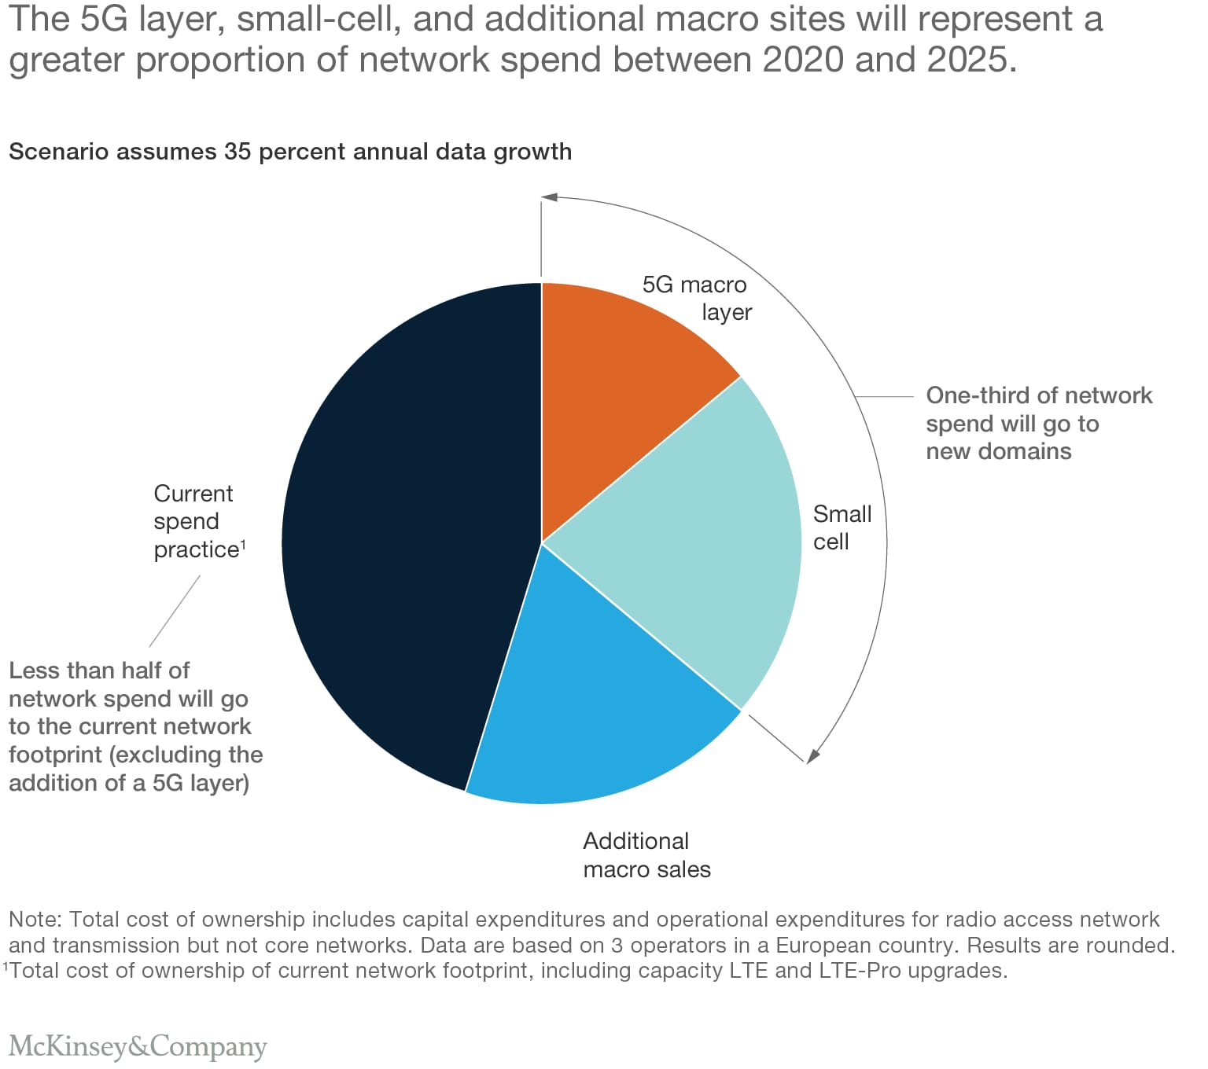
The DS-2TD6266-100C2L from Hikvision is a Thermal & Optical Bi-spectrum Network Positioning System applied to frontier defense occasions, maritime defense occasions, port monitoring, airport perimeter security, and so on. The pre-alarm system helps you discover unexpected events immediately and protects you from property loss.
Features:
- Smart Function (Thermal Imaging).
- Leading image processing technology: Adaptive AGC, DDE, 3D DNR, NETD < 40mk (@25°C, F#=1.0).
- Smart tracking: Panorama tracking, Event tracking and Multi-scene patrol tracking.
- Smart tracking linkage: thermal view and optical view.
- Powerful behavior analysis algorithm: Line crossing, Intrusion, Region Entrance & Exit.
- Reliable temperature exception alarm function.
- Advanced fire detection algorithm.
- Thermal Imaging Module Function.
- 640*512 resolution, high sensitivity sensor, support contrast adjustment.
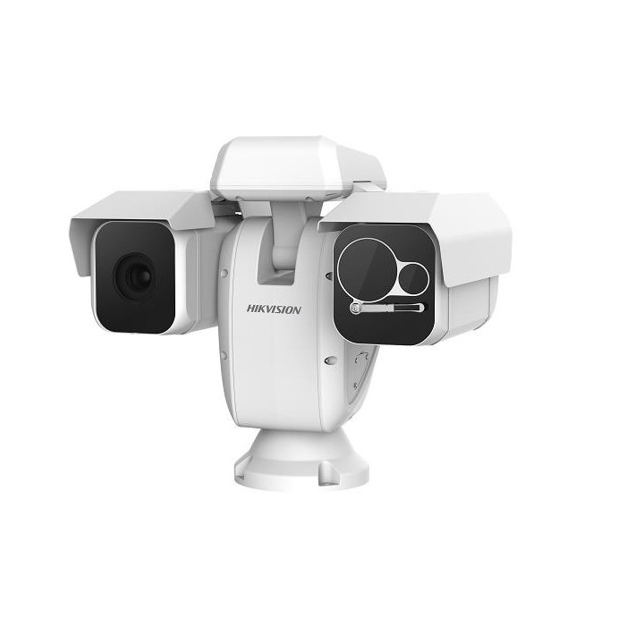

Hikvision DS-2TD6266-100C2L 640 X 512 Outdoor Network IR Thermal and Optical Bi-spectrum PTZ Camera, 49X Lens. Cost of the camera is $25,860.00

The Communications Sector
This is an integral component of the U.S. economy, underlying the operations of all businesses, public safety organizations, and government. Presidential Policy Directive 21 identifies the Communications Sector as critical because it provides an “enabling function” across all critical infrastructure sectors. Over the last 25 years, the sector has evolved from predominantly a provider of voice services into a diverse, competitive, and interconnected industry using terrestrial, satellite, and wireless transmission systems. The transmission of these services has become interconnected; satellite, wireless, and wireline providers depend on each other to carry and terminate their traffic and companies routinely share facilities and technology to ensure interoperability.

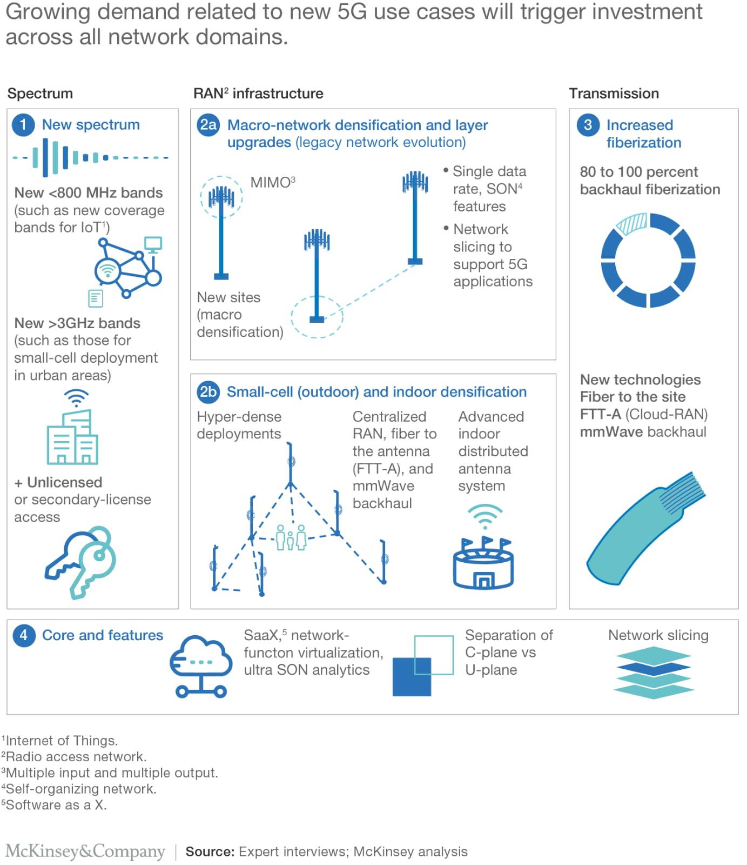
Cyber Threat Intelligence provides the means to collect, analyse and then sort all the data related to a cyber-attack, the attacker and the procedures used. Taking action as part of a community is one of the major challenges of Cyber Threat Intelligence insofar as it lets each player broaden their knowledge of attacks and protect themselves more effectively. Today, by sharing their analyses of cyber-criminal behaviours and procedures, Cyber Threat Intelligence teams are improving their knowledge of cyber threats in order to consolidate their ability to detect, anticipate new risks and fight cyber-attacks together.

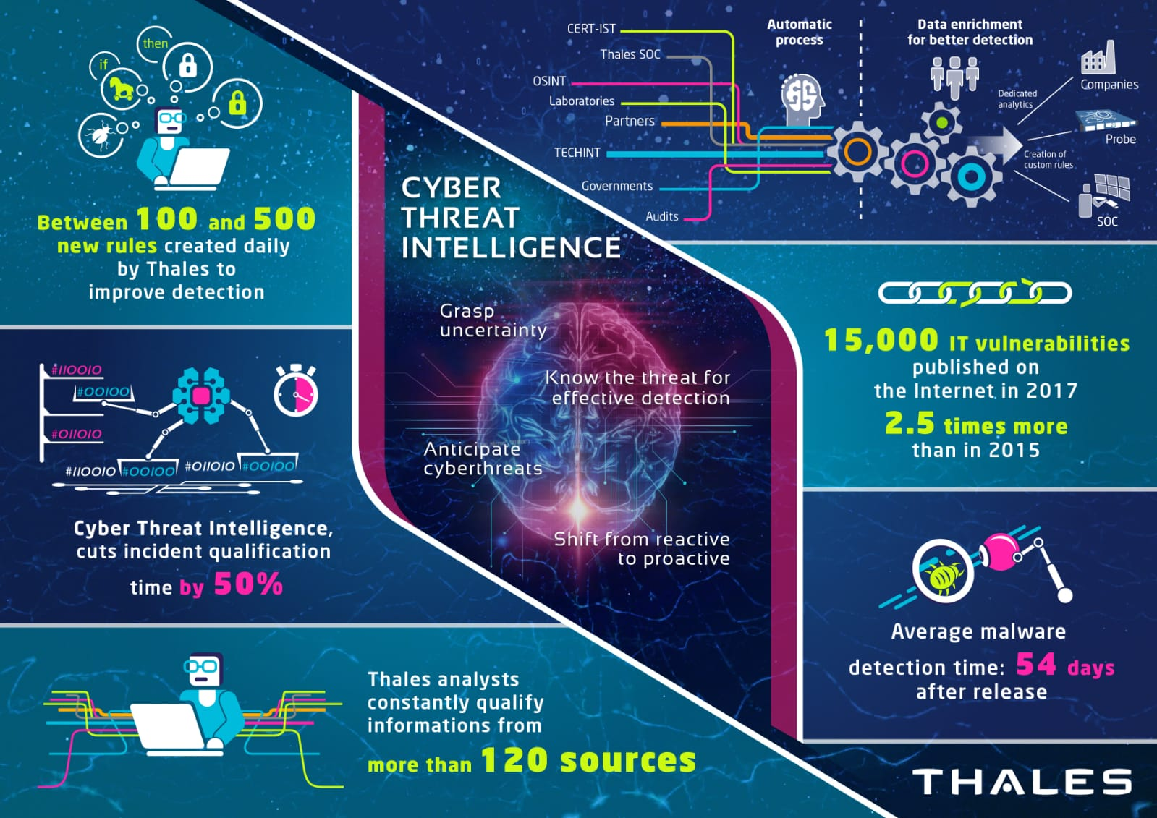

The cost to undertake a Cyber Threat Intelligence operation is $120,000.00 monthly.

The Government Facilities Sector
Includes a wide variety of buildings, located in the United States and overseas, that are owned or leased by federal, state, local, and tribal governments. Many government facilities are open to the public for business activities, commercial transactions, or recreational activities while others that are not open to the public contain highly sensitive information, materials, processes, and equipment. These facilities include general-use office buildings and special-use military installations, embassies, courthouses, national laboratories, and structures that may house critical equipment, systems, networks, and functions. In addition to physical structures, the sector includes cyber elements that contribute to the protection of sector assets (e.g., access control systems and closed-circuit television systems) as well as individuals who perform essential functions or possess tactical, operational, or strategic knowledge.

The VTOL Fixed Wing UAV Aerial Video Surveillance 3D Survey Mapping Drone, features vertical take-off and landing, has low requirements for landing and landing points, high operating efficiency, has a simple structure, and is easy to operate in a short time. It is capable of full autonomous flight, one-button take-off, is safe and efficient, has high security double protection for emergency landing and open umbrella. The duration of flight is 120 minutes, and the Aircraft Parameters Cruise speed is 60-100km/h. The aircraft length is 1.45m, wing width 2.5m, and the maximum take-off weight is 12kg. The Satellite navigation has [real-time GPS/GLONASS/Galileo/B Multi-system signal reception]; and it comes with high precision and high dynamic motion measurement.

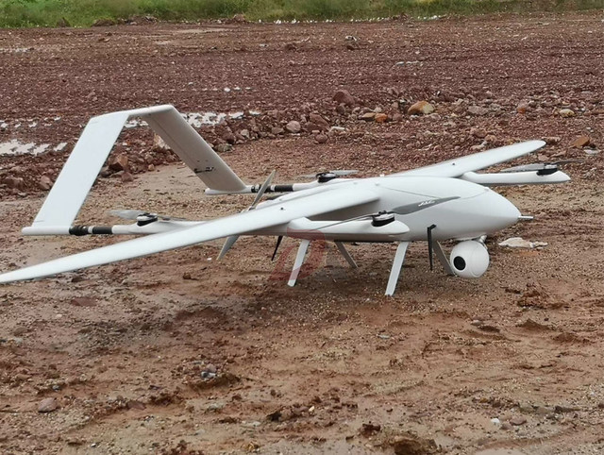

Images of the VTOL Fixed Wing UAV Aerial Video Surveillance Mapping Drone.
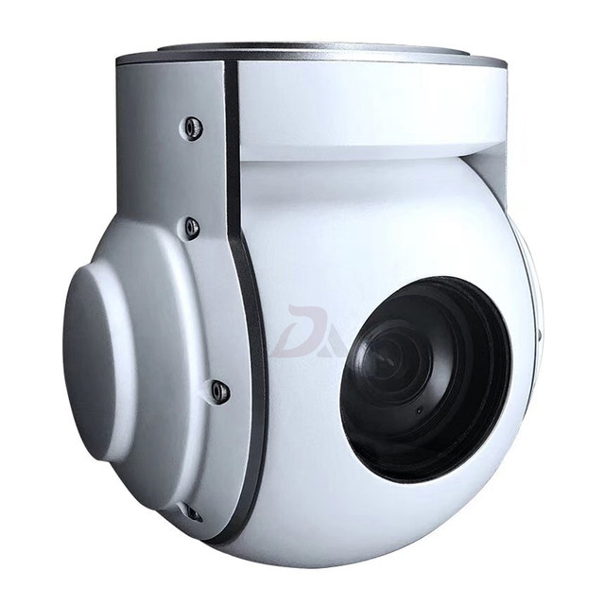
The camera of the drone.
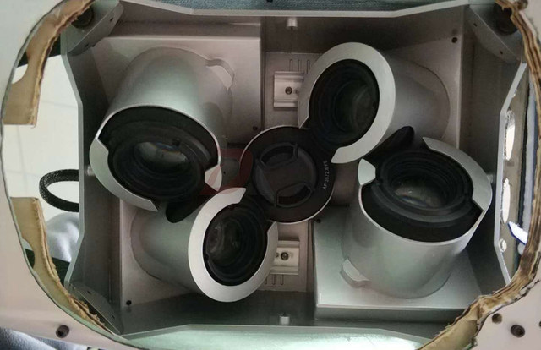

Different angles viewed from inside the camera.

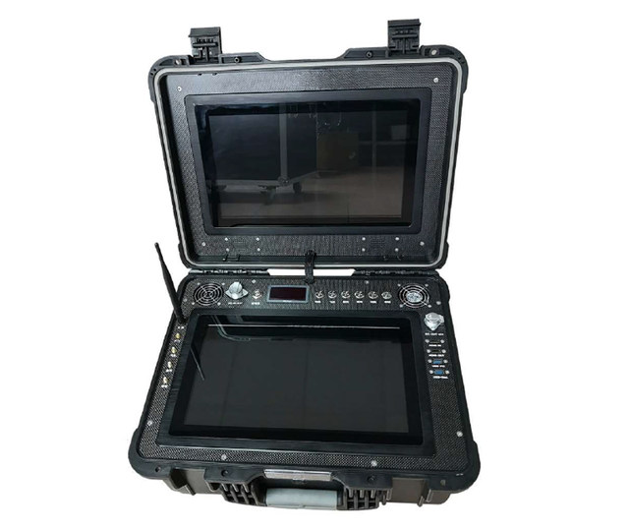
The drone data communications transponder.
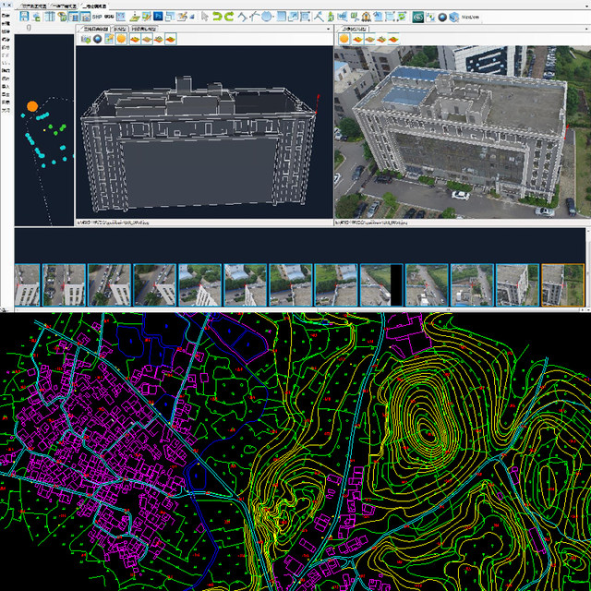
Imaging captured by the drone.

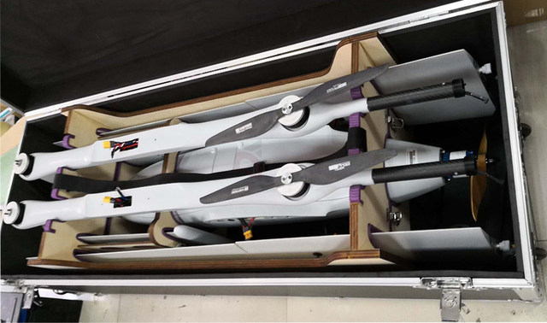

Electric Powered 2 Hours Endurance VTOL Fixed Wing UAV Aerial Video Surveillance 3D Survey Mapping Drone. The cost is $36,800.00.

Private Security Veterans Operation
This includes domestic and foreign entities, with assets located in different countries. The team provides services that are essential to mobilize, deploy, and sustain military operations. This does not include the commercial infrastructure of providers for services such as power, communications, transportation, or utilities, which are addressed by other Sector-Specific Agencies.

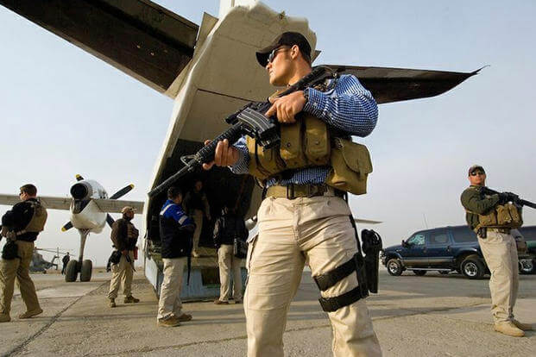

The private sector veteran operation’s main task is to fortify Peru's gold mine with armed forces and to assist in the planning operations (including psychological operations), training, logistics, intelligence, personnel management and drone surveillance coverage.
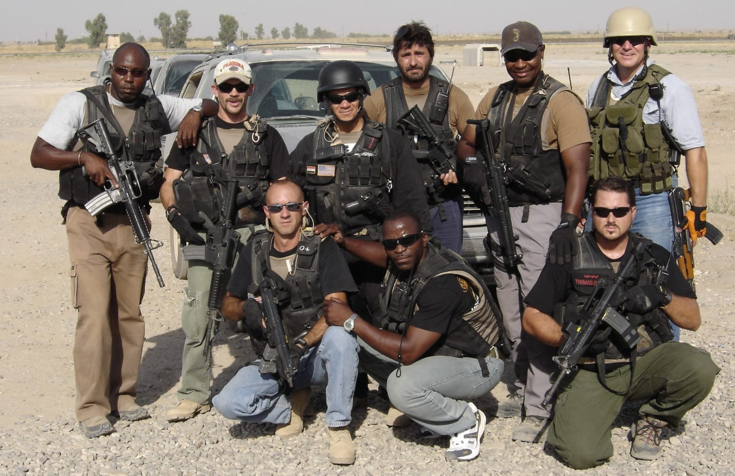

Contract Implementation is over an eighteen (18) month timeframe, and the cost is $1 to $3 million dollars for a 5 to 10-man team.

Budget for security infrastructure
The table below details the estimated budget for the security infrastructure as of September 2020. Rates applied for time and materials.
Description | Estimate
Cost of real-time data per month | $94,650.00
Hikvision camera equipment | $25,860.00
Cyber threat intelligence operation per month | $120,000.00
VTOL mapping drone equipment | $36,800.00
Private security veteran’s operation | $1-$3 million
Projected operational costs | $1,200,000.00
Total cost for security consultation | $4,477,310.00
This document has been presented by Mr. Jason Miller and team.

In the event you require additional information, please contact:

Mr. Jason Miller
Director of Research & Development
US & Latin Veterans Support Embassy
& The Veterans World Chamber
Tel: 954-928-7358

London
US & Latin Veterans Support Embassy
86-90 Paul Street
London
EC2A 4NE
E: amiller@uslvse.com>
Headquarters: Miami
US & Latin Veterans Support Embassy
1035 SW 12 Ct.,
Miami, Florida, 33135
Tel: 954-588-3670

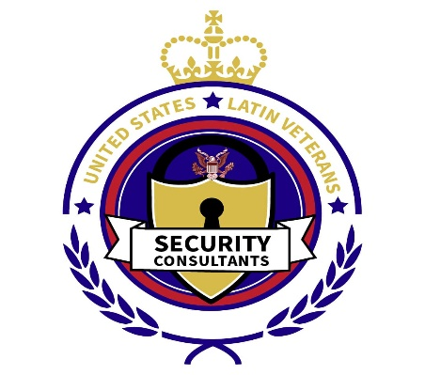
New York
Intergovernmental collaborative Action Fund for Excellence
Inc. ICAFE
17333 Croydon. Road. Jamaica Estates, New York 11432 USA

